EC Instance created:
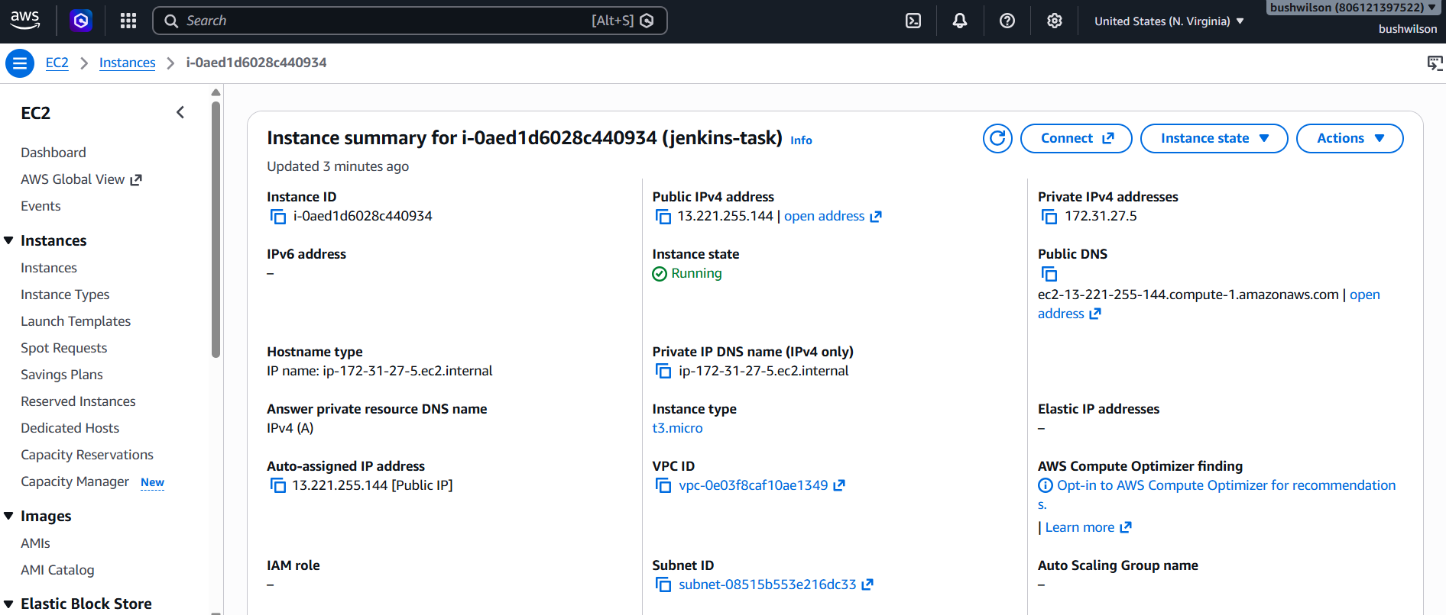
Installed Java:
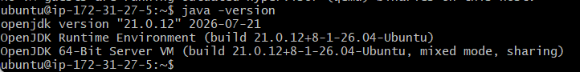
Installed Jenkins:
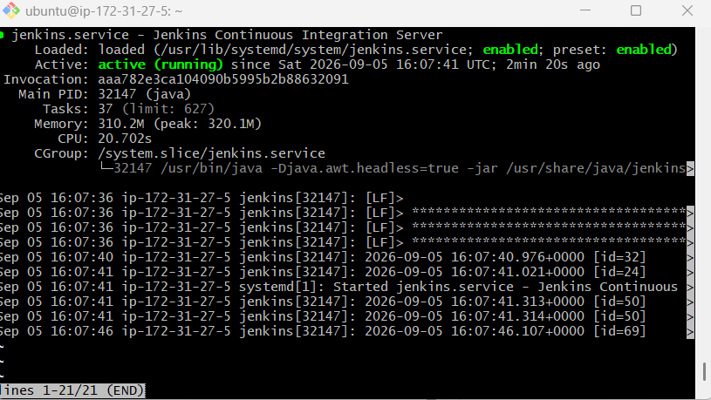

Connected via public IP of EC2:
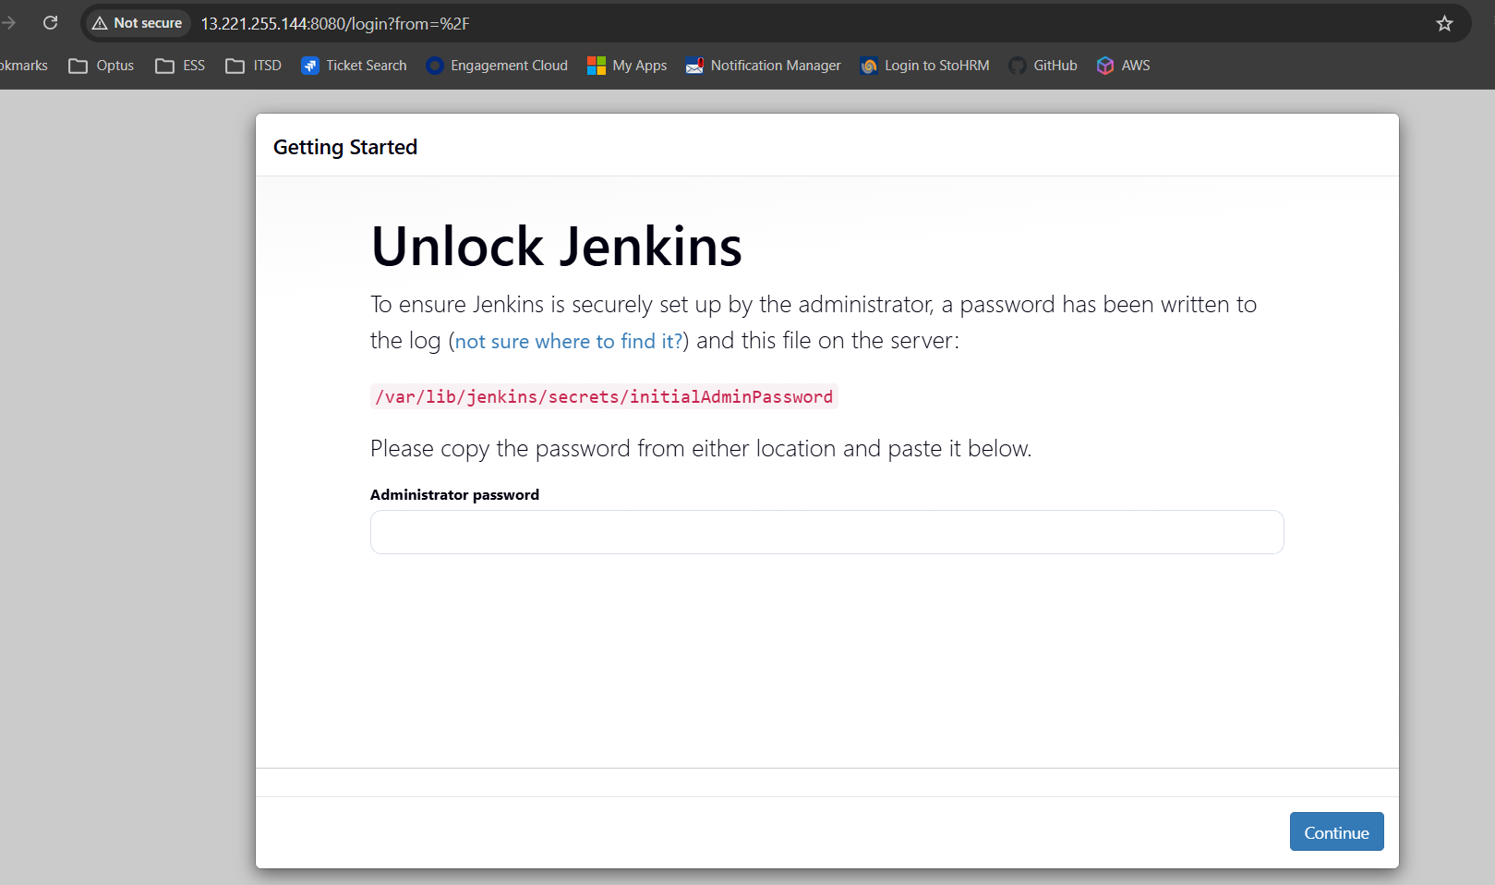
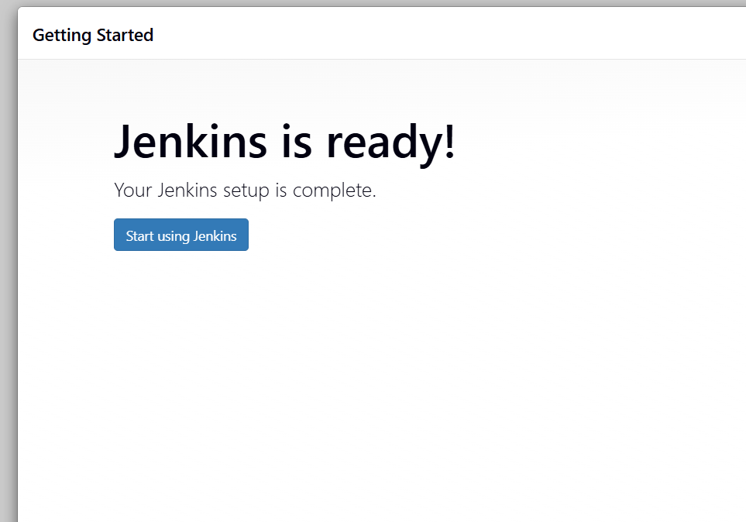

User Created in Jenkins:
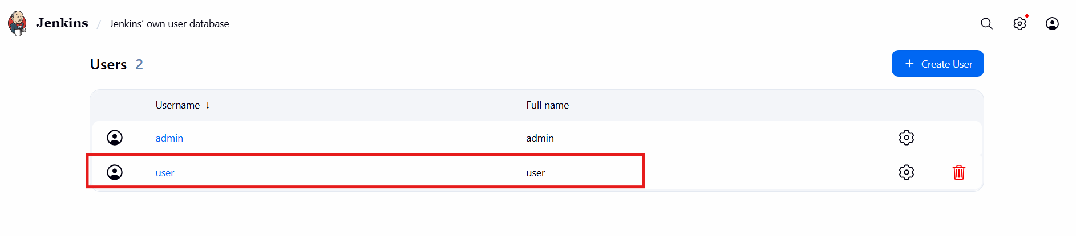
Project executed in Jenkins:
